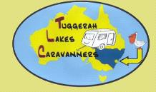

NEWSLETTER No. 165 December 2020
PO BOX 4028 Lake Haven 2263

Web address: Tuggerahlakescaravanners.net Facebook: Newsletter Caravanners TLC
President:  John Knight 4352 2264 / 0402 593 873  caravannerstuggerahpresident@gmail.com | Secretary:  Fay Thomas 0408 271 236  caravannerstuggerahsecretary@gmail.com
Vice President:  Fay Evernden 0409 201 146 | Treasurer:  Mike Collins 0407 280 018  caravannerstuggerahtreasurer@gmail.com
Editor:  Leonie Collins 0419 763 107  caravannerstuggeraheditor@gmail.com | Social Director:  Janis Treacy 0411 288 815  caravannerstuggerahsocial@gmail.com
Assistant Social Director: Helen Smyth 0484 229 861 | Welfare:  Jan Ryan 0421 886 059
Members Rep:  Norm Moore 4388 4556 / 0418 135 455 | State Rep:  Peter Davidson 0429 447 467
Please note that some of the Committee have email addresses with their names.
Email addresses have been created which will hopefully keep Club issues separate from private email addresses.
This will also be easier where a changeover occurs of office-bearers.

Disclaimer: The news items, written reports and/or comments expressed in Newsletters are by individuals and do not necessarily express the views of Tuggerah Lakes Caravanners Inc., the Editor or Members.

NEXT MEETING SUNDAY 17th JANUARY 2021

Members Birthdays January 2021
Cooper Des | 1-Jan | Wright Pam | 9-Jan
Steele Kevin | 1-Jan | Ryan Jan | 10-Jan
Luttrell David | 3-Jan | Marsland Ellen | 13-Jan
Pryde Frederick | 4-Jan | Kennedy Marilyn | 26-Jan
Majchrowski Richard | 6-Jan
Webster Barry | 7-Jan
Baird Chris | 11-Jan
Oakes John | 13-Jan
Davidson Peter | 21-Jan
Clarke John | 24-Jan
Belshaw Ron | 26-Jan
Petch Ken | 28-Jan
MERRY CHRISTMAS
&
A HAPPY, HEALTHY NEW YEAR

Christmas Lunch 13th December 2020
Held at Halekulani Bowling Club

80 Member attended a very enjoyable Christmas Lunch. The meal was excellent, with three meats, roast and steamed vegetables, followed by Christmas puddling with custard and cream.

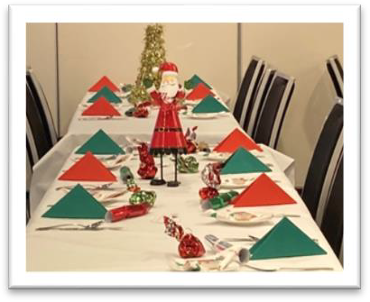
Everyone received a ticket for a drink (beer, wine or soft drink) and a lucky door prize ticket. Winners received a bottle of wine or what looked like a box of chocolates. Each place setting had a little bundle of sweets.
The tables were decorated by the Hali Club Thank you Janis and Helen for your organisation.
TLC Members provided the entertainment and kept us amused after the main meal.

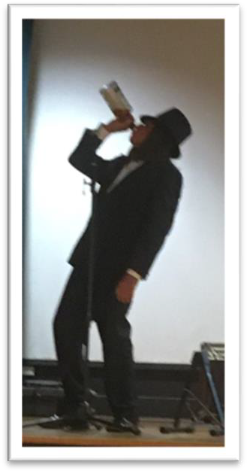
Alan Lindsay with Jokes and guitar, here he is moistening his vocal chords.

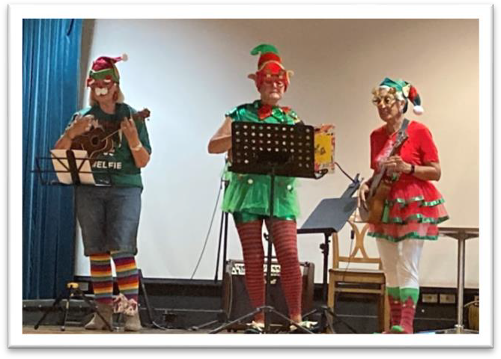
Alan was followed by the Three Elves = Helen Smyth, Fay Evernden and Beryl Howard who sang alternate carols. Their costumes were hilarious.

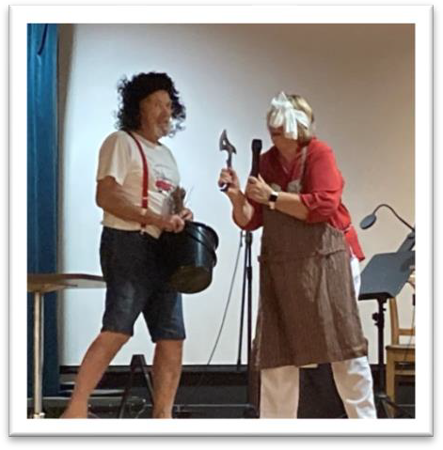
I was a bit concerned with the axe in the next act, thought that “Henry” was pushing his luck. This was a rendition of “There’s a hole in the bucket dear Henry” performed very well by Jan and Ross Ryan.

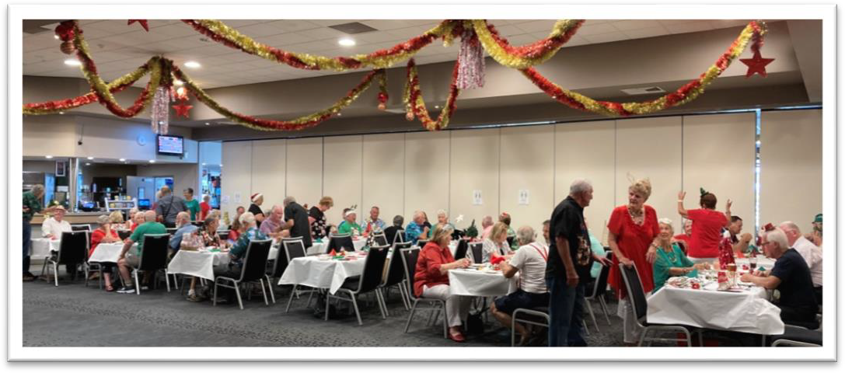

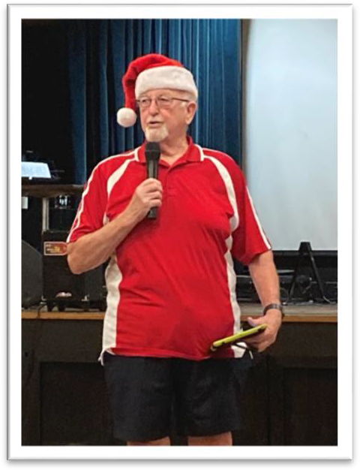
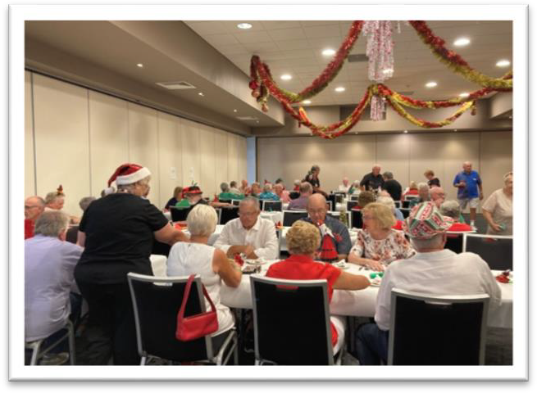
The last act was Des Cooper’s “Cockroaches” and joke.

As restrictions have eased a little it was great to be
able to mingle a bit more with other Members than we have been able to in the last few months

Scam Information
Graham Williamson sent through information on one of the latest scams.

WARNING: Be wary of accepting any "surprise gift or package," which you neither expected nor personally ordered, especially if it involves any kind of payment as a condition of receiving the gift or package. Also, never accept anything from someoe you do not personally know or there is no proper identification of who the sender is.

Often a phone call will come from a courier company saying that a delivery will be arriving soon which required a signature. The item arrives with a consignment note but no card identifying the sender.
In the example as the gift contained alcohol there was a $3.50 "delivery/ verification charge," providing proof that the courier had actually delivered the package to an adult (of legal drinking age), and not just left it on the doorstep where it could be stolen or taken by anyone, especially a minor. The item had to be paid by credit or debit card.
The card was put into a small mobile card machine, pin used and receipt received.

The end result was a $4000 charge/withdrawal from the account from various ATM machines. Obviously the card machine was able to copy the card, and a dummy card was created.

Above all, the only time you should give out any personal credit/debit card information is when you yourself initiated the purchase or transaction!

National Association of Caravan Clubs Limited

ABN: 40 141 272 844
Address: 15 Vantage Court
Bolwarra 2320 NSW Email: secretary@nacc.asn.au Web: www.nacc.asn.au Update from AGM and Board Meeting 28th October 2020
- AGM - meeting was held on 28-10-2020 at 10.00am EDST via video. In attendance list:- Adrian Skinner (CCQ); Ray Swift (ACT); Peter Hillas (ACCVic), Bob Williamson (ACCSA);
Rin Klasen (National); Nick Busuttil (NSW); Rob Taylor (ACCVic President); Derek Atkinson (WAACCI); Graham Brown (ACCSA President); Glen Arkinstall (NSW President)

Membership of the NACC is limited to the president of each state association. Individual club members cannot be members of NACC.

For the AGM, each state association president is invited to attend and only they (or their nominee) can vote at the AGM

The only change to the Directors/Alternate Directors was the appointment of Rob Taylor for ACCVic as alternate director for Peter Hillas.

Positions on the Board of Directors include Adrian Skinner (Chairman); Ray Swift (Treasurer); Rin Klasen (Secretary/Public Officer).

- Board of Director’s - meeting was held on 28-10-2020 at 10.30am EDST via video. Those attending this meeting were as listed for the AGM. Whilst only Directors or Alternate directors attend Board meetings, as a courtesy to those state presidents who have attended the AGM, they are invited to join the Board meeting.

- National Rallies
Spending figures for the 17th national rally in Albany have now been distributed to each state association for their information. As a matter of interest, over $1,700,000 was spent in getting to/attending and getting home from the rally. This figure comes from information supplied by club
members and is most likely very conservative since many members did not complete expense sheets.

The 18th National Rally planning is progressing well, and monthly newsletters are now being circulated to all affiliated club members. Registrations are now open with over 225 club members registered so far.
There is a special web site for the 18th National Rally. This can be accessed from the NACC web site nacc.asn.au or direct at https://www.18thnationalcaravanrally.org.au/welcome.php

The hope is that when Covid-19 restrictions are lifted, that more club members will register to attend what is shaping up to be a great national rally.

The NSW association has accepted the invitation to conduct the 2025 19th national rally and a committee has been formed to get the planning underway. Committee members are Chairperson - Frank Smalley; Treasurer - Ann Carragher; Assistant Treasurer - Damian Stewart; Ground Manager - Glen Arkinstall;, Entertainment Coordinator - Nick Busuttil.
The AREC site at Mudgee has been selected for the rally with dates set from 10/10/2025 to 20/10/2025. Pencil that date in your forward planners!

In 2028, the 20th national rally will be hosted by the Victorian association and believe it or not, but they have already started some preliminary work planning that event. Well done ACCVic.

- RV Clubs (RVCAL)
Since the last update, two meetings of RVCAL have been held. One on the 24th June and the AGM and Board meeting on 18th November. Both meetings have been conducted via video which is proving useful as it saves time and expense travelling to Brisbane.
RV Clubs has a new web site www.rvcal.net.au where you can download a copy of the Strategic Plan 2020
– 22. This web site is under construction and will be improved with further information available of interest to club members.

At the June meeting, the Australian Caravan Club were officially accepted as members of RVCAL and we are delighted to have them back.

- RV Clubs Rally
The original concept of holding a combined rally on the South Coast in early 2021 to support the bushfire communities, has run foul of the Covid-19 restrictions and has now been postponed to possibly 2022 depending on the conditions at that time.

- Correspondence
Just for interest, the NACC correspondence between March 2019 and March
2020 totalled 205 inward and 185 outward items. Covid-19 has kept things a bit quieter for obvious reasons.

- Financial Reports
Treasurer Ray Swift tabled the financial reports covering the period 1 Feb 2020 to 30

September 2020. Income was $6951.86 while expenses were $7,317.89 leaving a balance of $13,324.10

- Introducing a Director – Ray Swift (Treasurer)

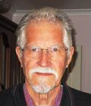
Ray Swift represents the ACT association and is a member of the Canberra Caravan Club. Ray has been actively involved with the national body since the early 1980’s, prior to the formation of the NACC as a company. He was appointed as a Director of the newly formed NACC Ltd in 2010 and as Treasurer in March 2012. Ray continues to hold the position of Treasurer and provides the Board with accurate and timely information on financial matters.

Many club members will remember Ray as Chairman of the organising committee for the 16th National Rally in Canberra. Ray, along with fellow Canberra club members delivered an excellent rally which, despite the weather, was a great success.
Issued 19/11/2020 Rin Klasen
Company Secretary/Director.

Narrabeen November 2020
Another yearly trip to Narrabeen. This year 15 vans in total attended Narrabeen, we had 24
on the list but due to the Covid Pandemic and other reasons the figure dropped to 15 vans only. We found that 15 was a very comfortable figure, it was just a great group, we had a lot of laugh’s and a wonderful time.
A few of us on the way to Narrabeen missed the correct turn and actually travelled down through the Connect M1 tunnel. I was one of them, it was a dreadful experience missing the turn. Before I knew it I had been shot into the new tunnel but then the drive through the tunnel was a wonderful experience seeing all the changing coloured lighting. I will never go that way again but it was a great experience - cost a few bucks.
I intended this to be my last year to Narrabeen and so I have handed over the trip coordination to John Bryce and Helen Tanner, they will be the new organisers at Narrabeen. As the week progressed I enjoyed myself so much that I decided I would return again next year.
This year I caught the bus from Narrabeen to Manly and hopped on the Manly Ferry at 9:30am with about 25 other people - I could not believe the ferry was vacant. I then left the Quay and hopped onto the Parramatta River Cat ferry. It was my intention to go to Parramatta but after half an hour I found out it would take one and a half hours to Parramatta then one and a half hours back so I jumped ship at Abbotsford and returned after 30 minutes to Barangaroo and then walked up into Darling Harbour, I must say there was not a lot of people around. I walked up to George Street and I then boarded the light rail destination Randwick and returned to the Quay. I legged it up to Wynyard Bus Terminal and then caught the B1 bus home. The B1 bus from Wynyard to Narrabeen has six stops, takes about 40 minutes a wonderful experience.

All members during the 10 days seemed to be extremely busy going to different events, playing golf and going out to dinners. John and Julie Wells organised a dinner for the full 39 people in what we called “the burnt out restaurant” because the restaurant has had a fire upstairs - we went downstairs the meal was absolutely wonderful. We also went to dinner at the Pittwater RSL club. Again we thought the crowds would be there but there was no one, we walked up purchased a beer easily and ordered our meal straightaway. The dinner again was excellent.

The whole Narrabeen experience this year was wonderful.
John and Helen have pencil booked about 50 sites for next November 2021 (8th to the 18th) we will not know the price until early August when Council makes its decision whether it will remain at
$46 per site.
On the local scene we saw three baby plovers hatched in our morning tea area it was quite exciting ducking diving parent plovers. We saw eight little ducks appear from the bushes not sure about their survival rate
Again we quite often experienced Narrabeen winds one of our members had a kind of twisted awning (one arm and the other a bit twisted but it was sprung back into position. A couple of other members were up in the middle of the night rolling up their awnings. The days where absolutely beautiful the nights were perfect for sleeping it was a wonderful trip.
Des Cooper

I hope all of you who travelled through the tunnel make sure that you register with your etag or similar provider for the toll rebate, and apply after that for your rebate. A copy of the form is at the end of the Newsletter as it is a full page it could not be fitted onto this page.

The address to send it is: cashback@transport.nsw.gov.au Or
Transport for New South Wales Cashback
Locked Bag 3
DUBBO NSW 2830
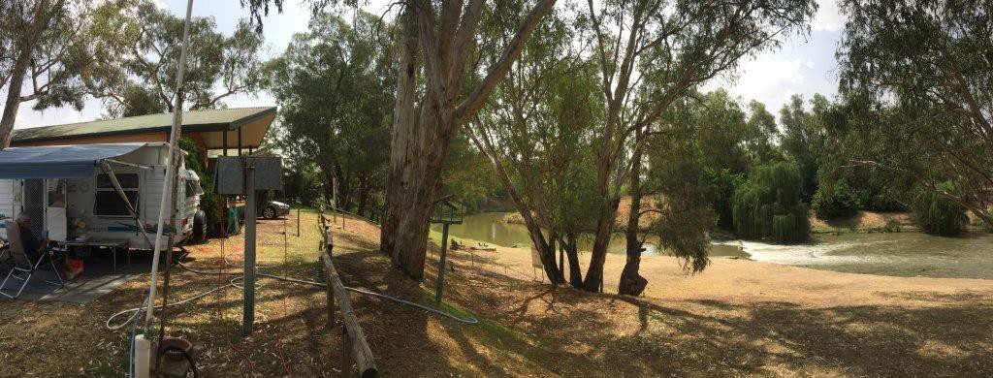

Chris Knights photo of “Little Toot” beside the Lachlan River at Forbes.

Silly Hat Jokes
Q: What do you get if you cross a cow, a sheep and a goat? A: A Milky Baa Kid

Q: What did the Martian say to the petrol pump?
A: Take your finger out of your ear when I’m speaking to you.

Q: What did the hat say to the scarf?
A: You hang around while I go on ahead.
Thank you Laurel & Roy, brings back a lot of memories. We must have followed you at places.

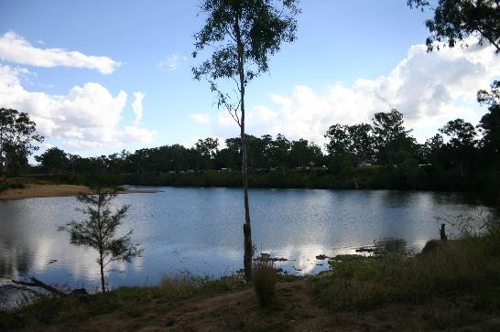
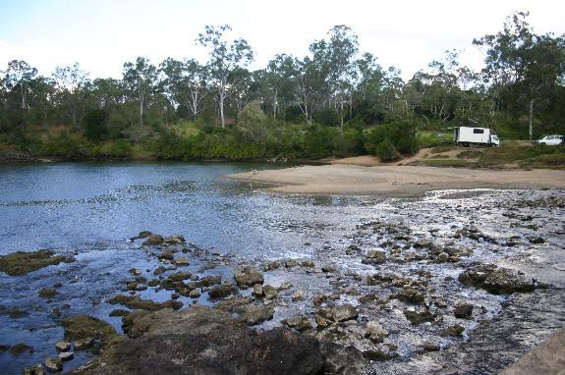
Trip to North West Queensland in 2013.

This is Calliope Rest Area very pretty stopover

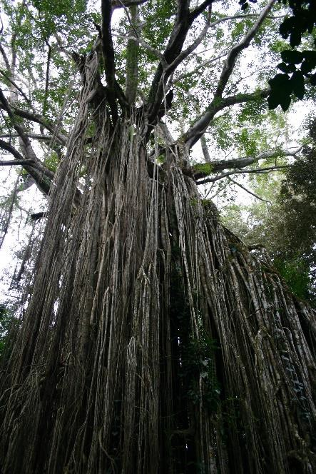
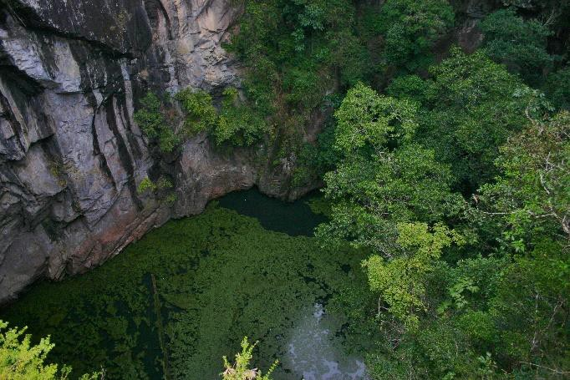
Atherton where Roy’s daughter Terri-Lee lives and took time off work to show our group around her area.

Curtain Fig Tree at Yungaburra

Eerie Mt Hypipamie Crater

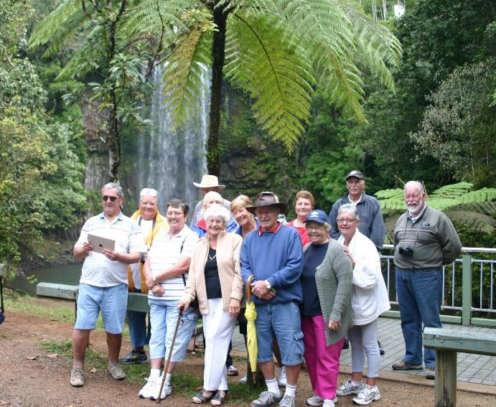
Our group at Milla Milla Falls

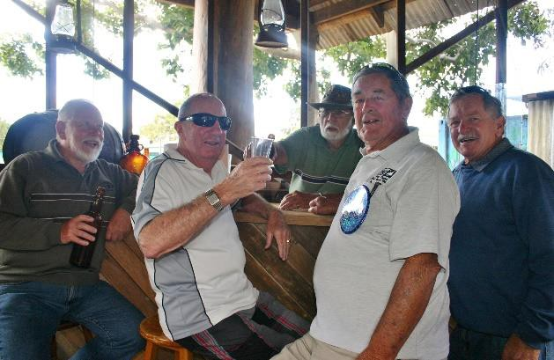
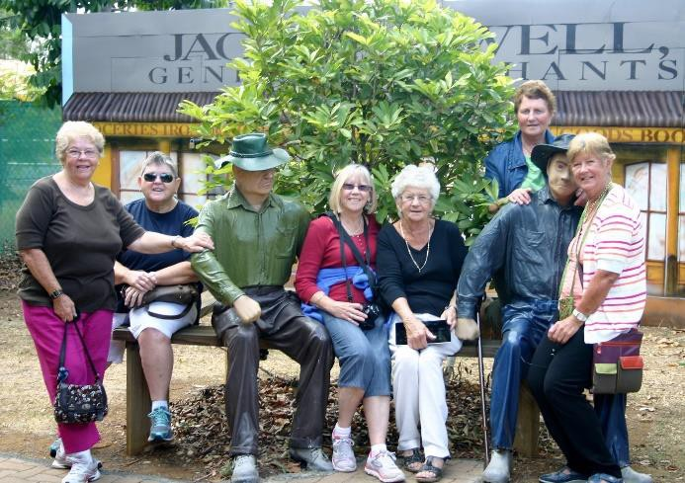
Mareeba Heritage Museum

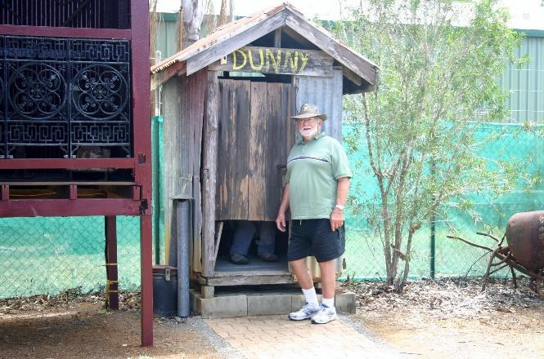
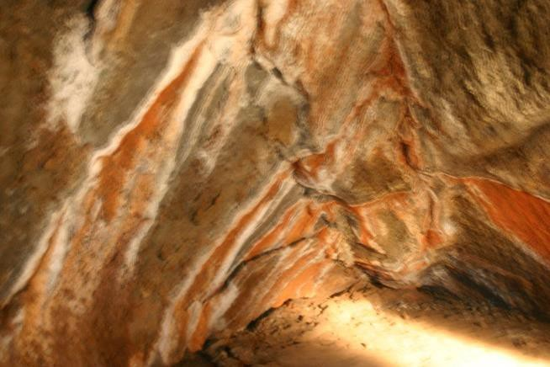
Roy can never resist a dunny

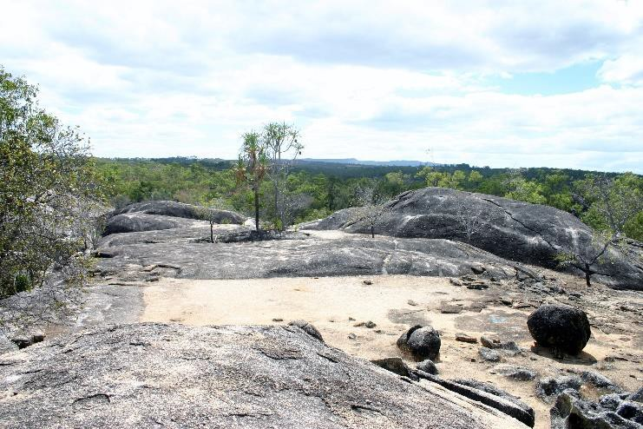
Granite Gorge, on our way back from Mareeba to Atherton Tablelands. Some did the hike, others just sat and chatted
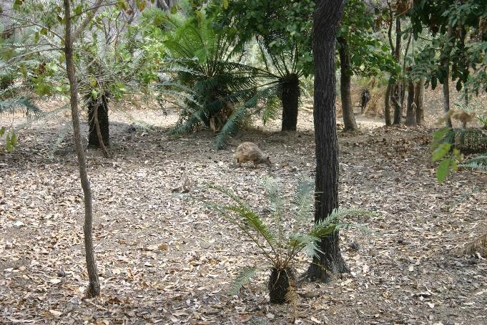

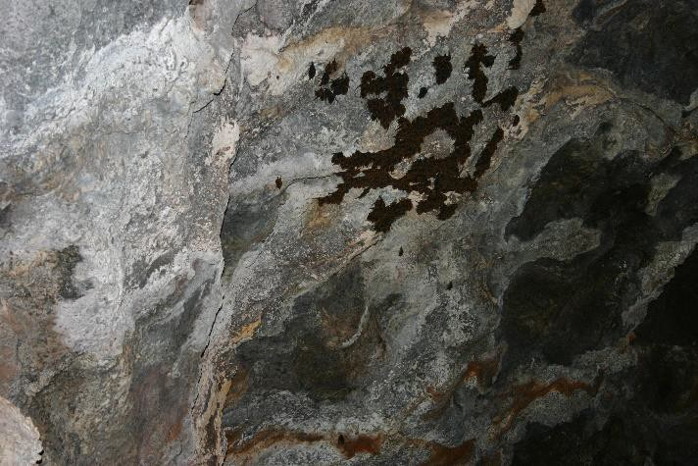
We stayed at Mt Surprise and went to the Undarra Lava Tubes Bats ugh

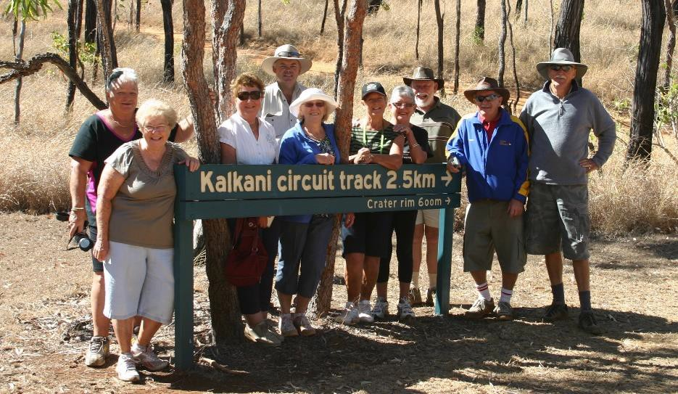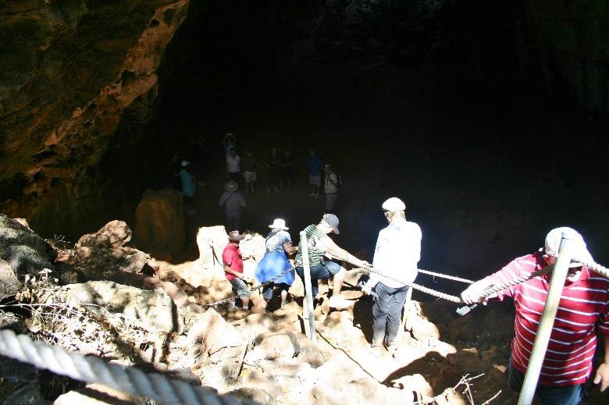
Hard going
climbing down , and back out again

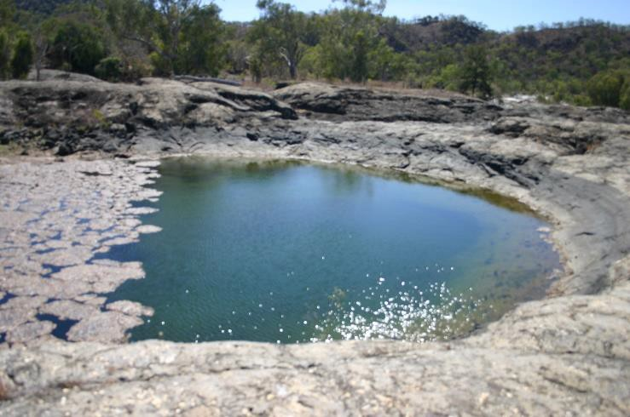

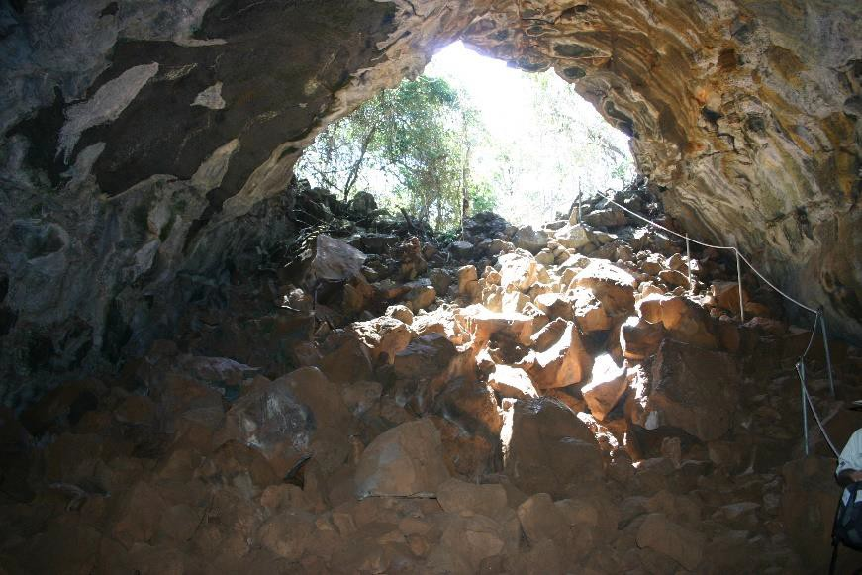
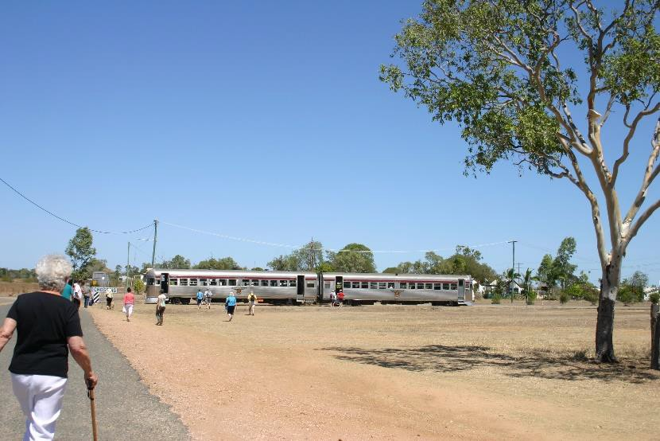
Quick the train is waiting

We went to Kurrimine Beach and walked out to the exposed reef.
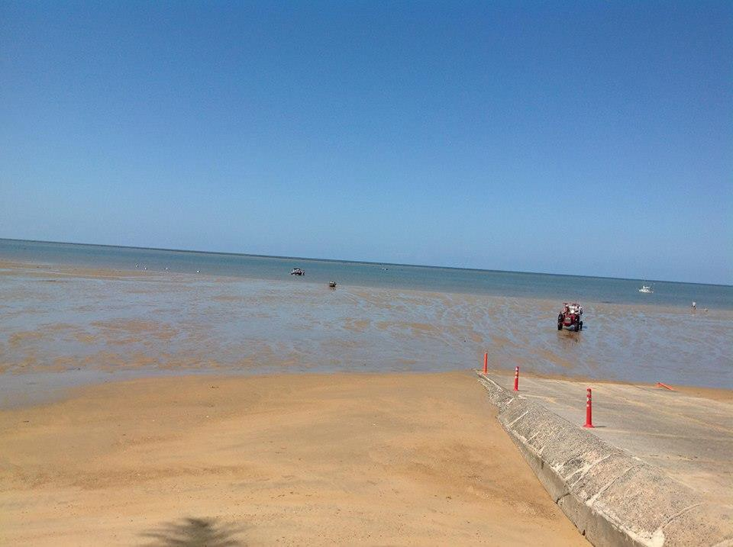
The boat ramp where we waded into the water The manager of the caravan park told me
there had not been a crocodile seen on the ramp for about 5 years. 1 1/2k out to reef and have to get back before tide turns. Lots of
marine life to see in the shallows
Bedrock Caravan Park took us in their little bus on a day trip to Einasleigh to see Copperfield Gorge and we travelled back to the park on the Savannahlander Train
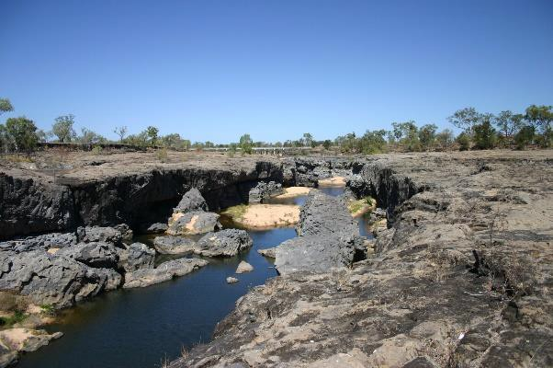

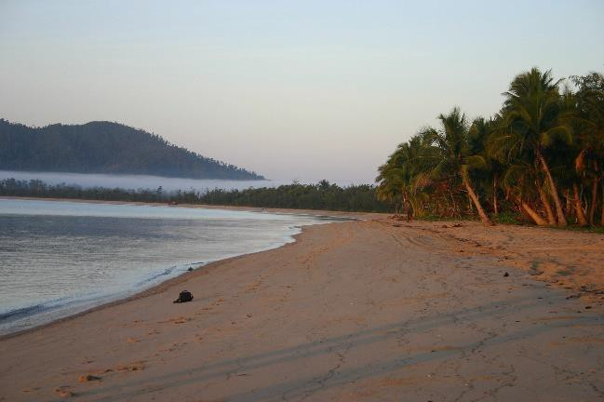

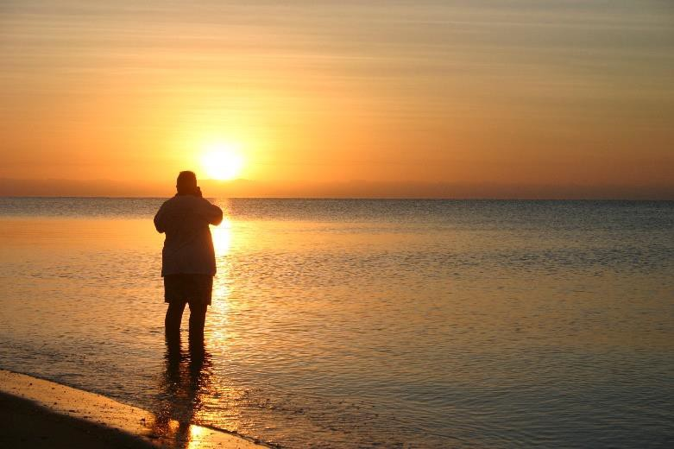
Jill and John Shawcross in van park pool

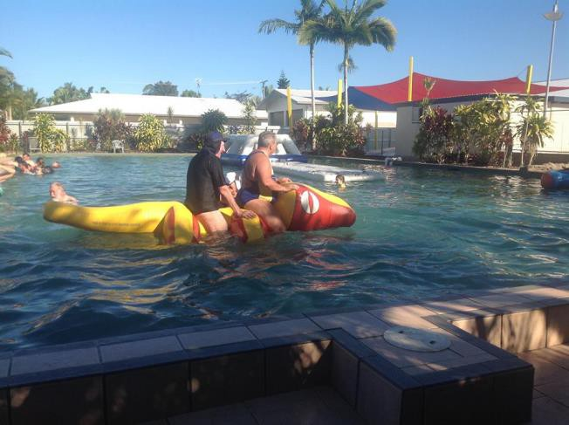

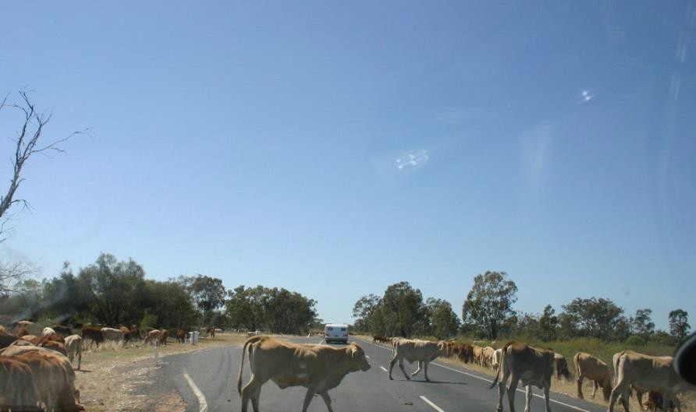
Sunrise at Kurrimine Beach with Jill

Cattle droving on the road between Roma and St George

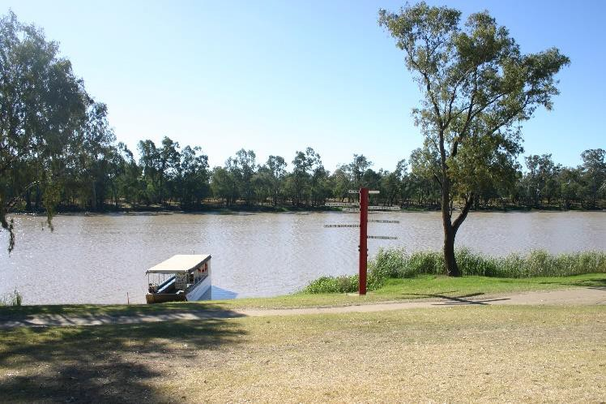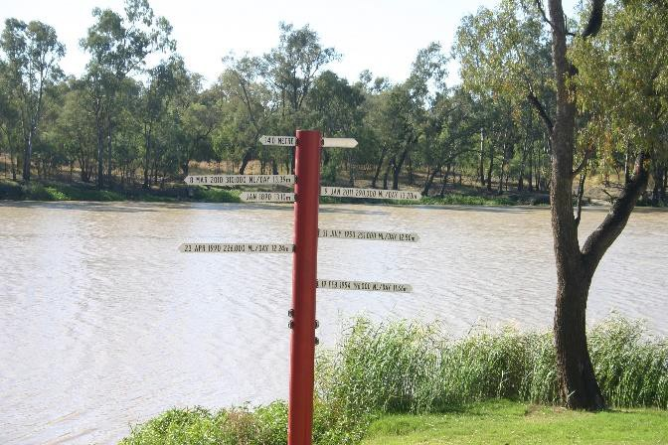
St George, the bank of the river showing flood markers.

WANTED | FOLD UP BIKE  Crane 20” fold up bike hardly used.  Ideal for the caravan trips for transport.  Comes with New helmet, wire basket and carry bag.  Inspect and pick up at Lisarow  $ 130 Phone Susan 0414 452317  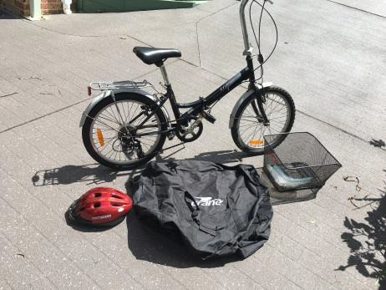  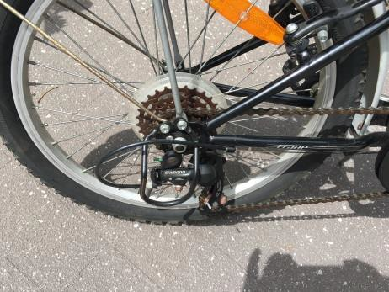  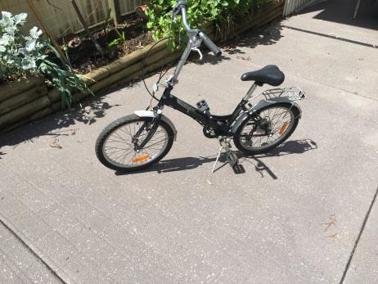
OLD SLIDE PROJECTOR
FOR
REFURBISHMENT
Phone Ian Palmer
0411 029 434
If any member requires Truma replacement bits.
Our Truma B14 HWS developed a leak and had to be replaced.
The 830 W element and circuit board are working well.
New element $ 320 this one $ 100
New circuit board $ 369 this one $100
Inspect and pick up at Lisarow
Ring Graham 0438 246662
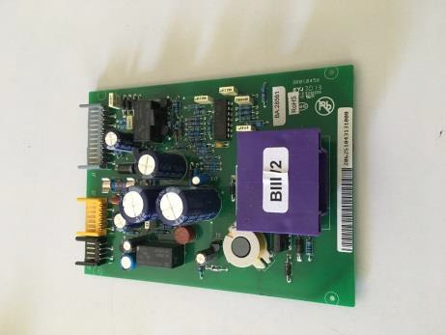
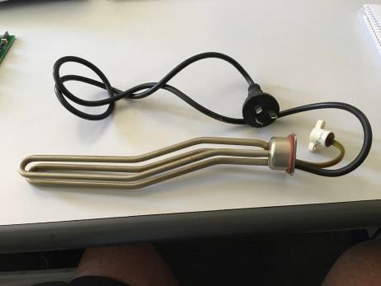

Tuggerah Lakes Caravanners
TRIP SHEETS 2021
DATES | DESTINATION | MEMBERS ATTENDING | CONTACT | PARK
Feb 4 – 11  2021 | Big 4 Great Lakes Tuncurry | Angell A/W, Barid/Bickley C/C, Brill H/C, Bryce/Tanner J/H, Collins M/L, Cornwell J, Cousins/Kennedy D/M, Cunneen/Wynberg S/G, Curnow R/L, Dawson K/R, Eadie H/M, Howard A/B, Insull B, Kane P/C, Knight J/C, Laney R/L, Latham D/B, Laurie N/W, Lee-Sing S/W, Lindsay F/A, McConville B/D, Maranik D/A, Marsland P/E, Merrett/Wright P/J, Moore N/J, O’Brien D/B, Palmer/Evernden I/F, Rogers R/R, Ryan J/R, Shawcross J/G, Smyth J/H, Steele K/L,  Treacy/Wenning J/R, Williams/Richardson K/L, Williams/Yarnton D/J, Williamson/Edwards G/S 36 | Coral & Peter Kane | Big 4 Tuncurry 6554  6827
Feb 11 – 18 | Big 4 Bulahdelah | Angell A/W, Barid/Bickley C/C, Collins M/L, Cornwell J, Cunneen/Wynberg S/G, Curnow R/L, Eadie H/M, Howard A/B, Insull B, Kane P/C, Knight J/C, Laney R/L, Latham D/B, Lee-Sing S/W, McConville B/D, Maranik D/A, Marsland P/E, O’Brien D/B,  Palmer/Evernden I/F, Rogers R/R, Shawcross J/G, Smyth J/H, Treacy/Wenning J/R, Williams/Richardson K/L, 24 | Coral & Peter Kane | Big 4 Bulahdelah 4987  9281
Mar 4 – 11 | Reflections Holiday Parks Urunga | Angell A/W, Cok A/W, Collins M/L, Cook J/D, Cooper D, Cornwell J, Edwards/Williamson S/G, Fraser T/A, Geale W, Henry M/V, Holmes L/J, Howard A/B, Insull B, Kane P/C, Knight J/C, Laney R/L, Latham B/D, Lee-Sing S/W, Lindsay F/A, McConville B/D, Maranik A/D, Merrett/Wright J/P, Oakes J, Olesen P/C, Palmer/Evernden I/F, Pryde/Nutter F/R, Rohwer P/P, Smyth J/H, Steele K/L, Tanner/Bryce H/J, Thomas R/F, Treacy/Wenning J/R, Wells J/J, Wilcox/Richardson  G/J 34 | Club Organised | Reflections Holiday Park Urunga 6655 6355
Mar 15 – 19 | Barrington Camp | Bickley/Baird C/C, Cok W/A, Collins L/M, Cooper D, Cornwell J, Geale W, Jones D/S, Laurie N/W, Lee-Sing S/W, Merrett J, Steele K/L, Thomas F/R, Wilcox/Richardson G/J 13  Reserves: | Mike Collins 0407-280-018
March 22 – Apr 4 | Hartwood  Campfire & Country Music | Collins M/L, Cooper D, Geale W, Howard B/A, Rohwer P/P, Smyth J/H 6 | Mike Collins 0407-280-018 | Hartwood 0456 780 824
Apr 19 – 26 | NRMA Dubbo Holiday Park | Bennett M/B, Cok W/A, Cook J/D, Cooper D, Cornwell J, Cousins/Kennedy D/M, Howard B/A, Insull B, Latham D/B, Lee-Sing S/W, Merrett/Wright J/P, Mizon/Eames K/J, Palmer/ Evernden I/F,  Rohwer P/P, Thomas R/F, Treacy/Wenning J/R, Wilcox/Richardson G/J 17 | Janis Treacy | NRMA Dubbo 6867  9448

